Question 11 pts
Based solely on the regression equation, Y = 5.5X - 10.7, which of the following statements is accurate?
 | The regression line crosses the Y axis in the negative range of the axis.
 | The regression model has a strong predicting power.

The regression line goes from the upper left corner to the lower right corner of the scatter plot.
Linear function is the best way to capture the data in the sample.

Flag this Question
Question 21 pts
Which part of the following SPSS output represents the "a" in the regression equation Y=bX+a.
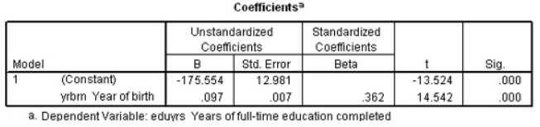
.097
12.981

-175.554
.362

Flag this Question
Question 31 pts
What can be concluded we know the ANOVA test on a regression model has a p of .025.?
The regression model does not have a significant predicting effect on the outcome variable (assuming an alpha level of .05) and the effect size is unknown.
The regression model has a weak to medium predicting effect on the outcome variable but it is unknown whether the effect is significant or not.

The regression model has a significant predicting effect on the outcome variable (assuming an alpha level of .05) and the effect size is unknown.
The regression model has a significant predicting effect that is weak to medium in size on the outcome variable.

Flag this Question
Question 41 pts
A bivariate regression analysis was performed on a sample with 30 subjects. What are the two degrees of freedom to be reported in the omnibus F test result?
F (2, 29)
F (1, 28)

F (1, 29)
F (2, 28)

Question 51 pts
The t test performed on an individual predictor in a regression model is testing the null hypothesis that ____.
the regression model containing this predictor has no predicting effect on the outcome variable.
the model fit is not different from zero

the shared variance between the predictor and the outcome variables is not different from zero
the coefficient of the predictor is not different from zero

Flag this Question
Question 61 pts
Which of the following statements accurately describes the line represented by the regression equation?
It is a line that goes from the lower left corner to the upper right corner of the graph.
It is the line that minimizes the deviations of the data points from the line.

It is the line where all the data points are located.
It is a line that always crosses the point where both X and Y are 0.

Flag this Question
Question 71 pts
Based on the SPSS output below, how much of the variance in the outcome variable can be explained by the regression model being tested?
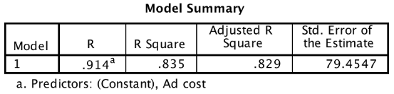
91.4%
79.45%

82.9%
83.5%

Flag this Question
Question 81 pts
From the SPSS output table for a bivariate regression, identify the number that will indicate the "slope" of the linear function.
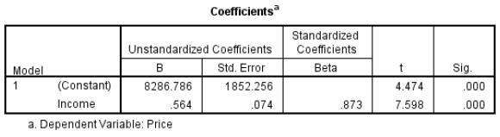
.873
.074

.564
7.598
Question 91 pts
A bivariate regression analysis is different from a bivariate correlation analysis in that ____.
In a bivariate regression analysis, one variable is designated as the predictor while the other is designated as the outcome. A bivariate correlation is bi-directional, on the other hand.
The goal of a bivariate correlation is to to use one variable to predict the other through the correlation coefficient, r.

The proportion of variance in one variable accounted for by the variance in the other variable can be calculated through a regression but not a correlation.
A causal relationship between two variables can only be revealed through a regression analysis but not a correlation analysis.

Flag this Question
Question 101 pts
Before performing a bivariate regression analysis, a Pearson bivariate correlation was performed on the two variables. According to the output below, what is the adjusted R² for the bivariate regression model?
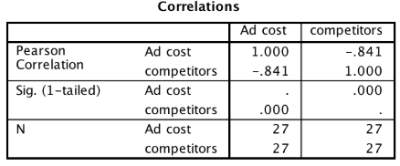
.841
a little lower than 841

A little lower than .707
.707

Flag this Question
Question 111 pts
Which of the following is a requirement for conducting a multiple linear regression?
The hypothesized regression line crosses the Y axis at the "0" point.
The predictors all have positive bivariate correlations with the outcome variable.

None of the predictors have significant bivariate correlations with other predictors.
The hypothesized relationship between the predictors and the outcome variable is supported by a theory or existing research evidence.

Flag this Question
Question 121 pts
Which statement is accurate about multiple linear regression?
The effect of each individual predictor is tested through an F test.
The strength of the Pearson's correlation between a predictor and the outcome variable is usually weaker than that of the semipartial correlation between the same two variables.

Removing a predictor from a multiple regression model always lowers the effect size of the model.
Using the method of "Forward" to build a multiple regression model in SPSS should result in a model with only significant predictors.
Question 131 pts
What unique information can be gleaned from a multiple linear regression that is not available from a bivariate linear regression?
The measure of how well the model fit the data set.
The parameters of the regression equation for predicting the outcome variable.

The relative contributions from different predictors to the regression model.
Whether the model effect can be generalized to the population.

Flag this Question
Question 141 pts
In the SPSS output tables below, the change amount in Adjusted R² from .754 to .771 indicates _____.
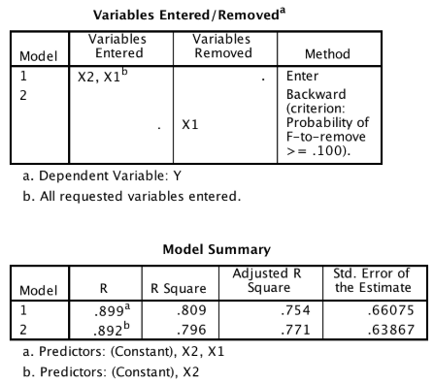
The increased effect of the predictor X₂ in predicting the variance of the outcome variable.
The increased effect of the predictor X₁ in predicting the variance of the outcome variable.

The increased proportion of the outcome variance that can be explained by the model due to the inclusion of X2.
The increased proportion of the outcome variance that can be explained by the model due to the removal of X₁.

Flag this Question
Question 151 pts
High multicollinearity affects primarily which aspect of multiple regression analysis?
Estimation of the model fit.
Estimation of the individual predictor's regression coefficient.

Estimation of the parameters of the regression equation.
Estimation of the F statistic.

Flag this Question
Question 161 pts
Which statement is accurate based on the SPSS output for a multiple regression model?
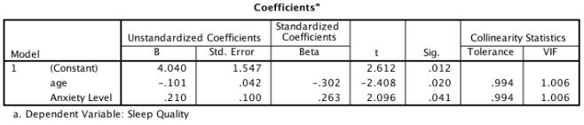
The multiple regression model suffers from the multicollinearity problem so the result is not reliable.
The regression equation would be Y = -.101X₁ + .210X₂ (Y=Sleep quality, X₁=age, X_{2=Anxiety level)}

Age is the only significant predictor in the regression model for predicting sleep quality.
Age is the predictor that has the strongest effect in the regression model for predicting sleep quality.
Question 171 pts
The following SPSS output table indicates that the regression model was built with the _____ method.
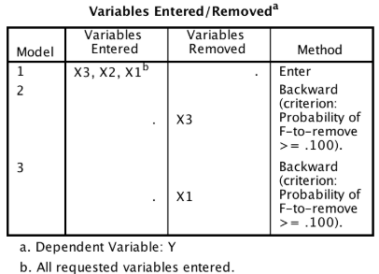
ENTER
FORWARD

BACKWARD
STEPWISE

Flag this Question
Question 181 pts
Which statement is accurate based on the SPSS output for multiple regression with two predictors below?
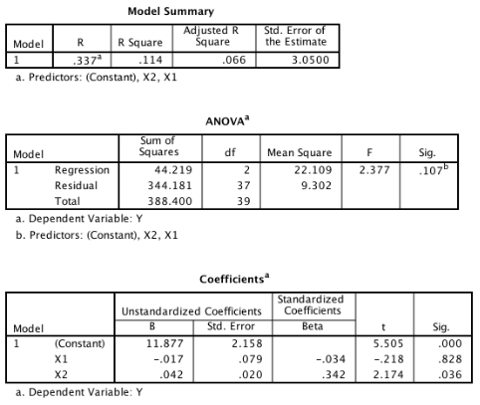
X₁ is a significant predictor but X₂ is not.
Predictor X₂ has a significant effect in predicting the outcome variable but the model with both X₁ and X₂ as predictors is not significant.

The model is not significant so neither predictors have a significant effect in predicting Y.
The model is significant in predicting the outcome variable so both X₁ and X₂ are significant predictors.

Flag this Question
Question 191 pts
What is the best measure for evaluating the relative contributions of the individual predictors in a multiple regression?
t
p

β
VIF

Flag this Question
Question 201 pts
Which statement is accurate based on the following SPSS output for a multiple regression model?
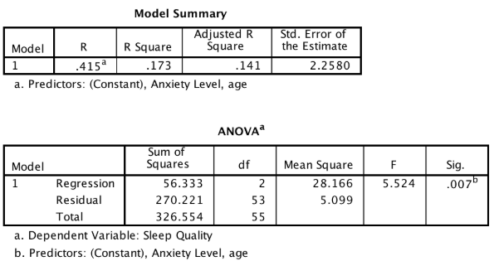
The sample size is 56.
Because the R is positive, both predictors have positive correlations with the outcome variable.

The model can explain 41.5% of the variance in the outcome variable.
The F statistic is .007.

